**DELETE CODE**

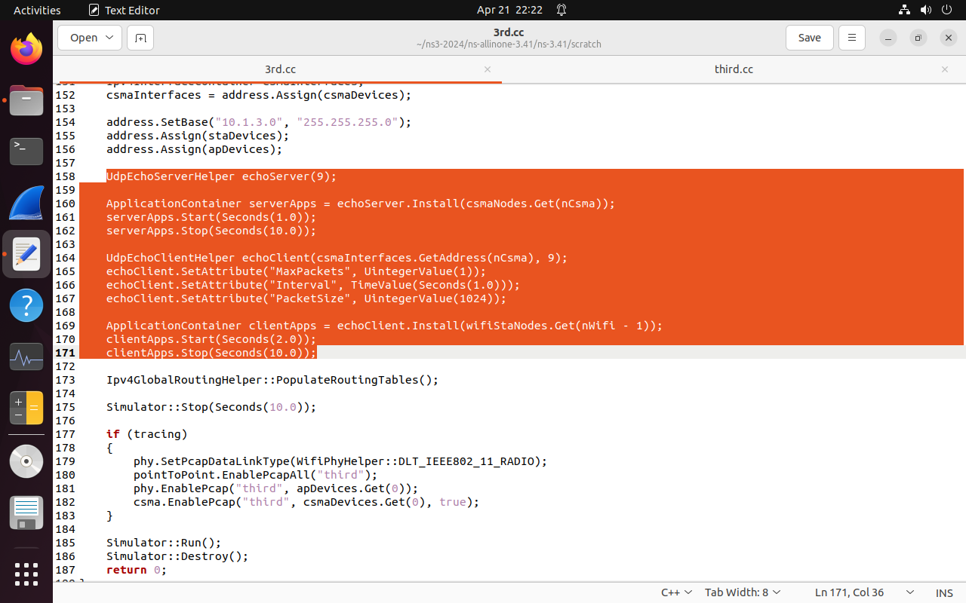

Delete these in traffic control and then paste it in lab3.cc after Simulator::Run() (it will be explained in next page)

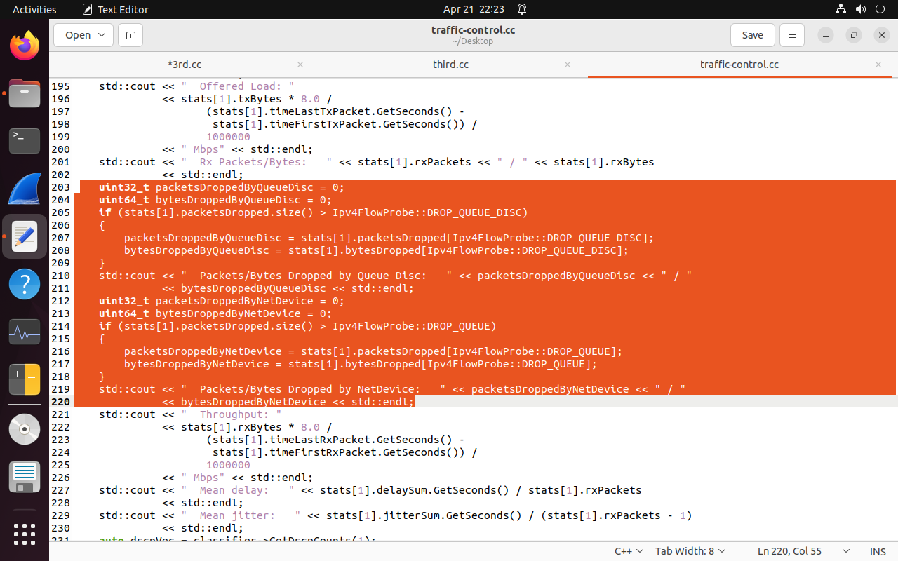

**CHANGES IN CODE**

#include "ns3/flow-monitor-module.h"

//copy code from traffic-control.cc and paste in lab3.cc and make changes

// Flow

uint16_t port = 7;

Address localAddress(InetSocketAddress(Ipv4Address::GetAny(), port));

PacketSinkHelper packetSinkHelper(**"ns3::UdpSocketFactory"**, localAddress);

ApplicationContainer sinkApp = packetSinkHelper.Install(**csmaNodes.Get(nCsma)**);

sinkApp.Start(Seconds(0.0));

sinkApp.Stop(Seconds(**10** + 0.1));

uint32_t payloadSize = 1448;

Config::SetDefault("ns3::TcpSocket::SegmentSize", UintegerValue(payloadSize));

OnOffHelper onoff**("ns3::UdpSocketFactory"**, Ipv4Address::GetAny());

onoff.SetAttribute("OnTime", StringValue("ns3::ConstantRandomVariable[Constant=1]"));

onoff.SetAttribute("OffTime", StringValue("ns3::ConstantRandomVariable[Constant=0]"));

onoff.SetAttribute("PacketSize", UintegerValue(payloadSize));

onoff.SetAttribute("DataRate", StringValue("50Mbps")); // bit/s

ApplicationContainer apps;

InetSocketAddress rmt(**csmaInterfaces**.GetAddress(**nCsma**), port);

rmt.SetTos(0xb8);

AddressValue remoteAddress(rmt);

onoff.SetAttribute("Remote", remoteAddress);

apps.Add(onoff.Install**(wifiStaNodes.Get(nWifi-1)**));

apps.Start(Seconds(1.0));

apps.Stop(Seconds(**10** + 0.1));

FlowMonitorHelper flowmon;

Ptr<FlowMonitor> monitor = flowmon.InstallAll();

//Again copy code from traffic-control.cc and paste after **Simulator::Run()**

Ptr<Ipv4FlowClassifier> classifier = DynamicCast<Ipv4FlowClassifier>(flowmon.GetClassifier());

std::map<FlowId, FlowMonitor::FlowStats> stats = monitor->GetFlowStats();

std::cout << std::endl << "*** Flow monitor statistics ***" << std::endl;

std::cout << " Tx Packets/Bytes: " << stats[1].txPackets << " / " << stats[1].txBytes

<< std::endl;

std::cout << " Offered Load: "

<< stats[1].txBytes * 8.0 /

(stats[1].timeLastTxPacket.GetSeconds() -

stats[1].timeFirstTxPacket.GetSeconds()) /

1000000

<< " Mbps" << std::endl;

std::cout << " Rx Packets/Bytes: " << stats[1].rxPackets << " / " << stats[1].rxBytes

<< std::endl;

//add these line

**std::cout << " lost Packets/Bytes: " << stats[1].lostPackets**

**<< std::endl;**

std::cout << " Throughput: "

<< stats[1].rxBytes * 8.0 /

(stats[1].timeLastRxPacket.GetSeconds() -

stats[1].timeFirstRxPacket.GetSeconds()) /

1000000

<< " Mbps" << std::endl;

std::cout << " Mean delay: " << stats[1].delaySum.GetSeconds() / stats[1].rxPackets

<< std::endl;

std::cout << " Mean jitter: " << stats[1].jitterSum.GetSeconds() / (stats[1].rxPackets - 1)

<< std::endl;